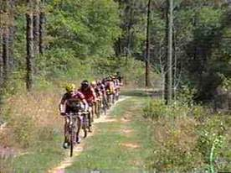

1ST ANNUAL
HAYES COUNTY FESTIVAL
GRAVEL ROAD BIKE TOUR 8 A.M. - 5 P.M.
$35 PER RIDER
JUNE 29, 2019
Course will begin at Wellfleet, wander through canyons /pasture land around Camp Hayes, all on gravel/sand county roads
Water and restroom provided every 10 miles, snack break at Camp Hayes
TOUR ENDS AT FARKLEBERRY’S/MIDWAY MOTEL
Food, drinks, prizes, beer garden and entertainment provided
ENTRIES CAN BE FOUND ON FACEBOOK UNDER HAYES COUNTY VISITORS COMMITTEE OR BY CONTACTING CONNIE BROTT 308-350-5001
NO PRE-ENTRY REQUIRED
T-SHIRT NOT GUARANTEED FOR ENTRIES AFTER JUNE 15TH

